Golf Fitness Manual

TABLE OF CONTENTS

- INTRODUCTION

- GOLF FITNESS CULTURE OF GOLFRSA

- DANGERS FACING THE YOUNG GOLFER: EARLY SPECIALISATION

- GOLF ALL YEAR ROUND: THE CHALLENGE WITH TOURNAMENT SCHEDULE

- GOALS OF GOLF FITNESS

- COMPONENTS OF GOLF FITNESS

- INJURIES: THE BLACK MARK THAT NEVER GOES AWAY

- WARM UP AND PREP

- COOL DOWN AND RECOVERY

- NOTES ON NUTRITION

- REFERENCES

1. INTRODUCTION

Golf fitness has long become the norm around the elite golf circles, emulating what the professional golfers are doing on tour. The proverbial “golfing athlete” has become a reality and most golfers are spending more time looking after their bodies in the gym, on the physio bed and in the kitchen.

GolfRSA, under the guidance of Grant Hepburn, made an intentional decision in April 2017 to employ the services of a Golf Fitness Specialist (GFS). The role of the GFS is to consult directly with GolfRSA on all matters fitness, from warm up and recovery routines, to training camps, assessments, injury management and education for players, parents, coaches and the golf unions that GolfRSA partners with and developing our prodigious golfing talent in this country. This GFS will aim to help create a positive culture within the squads around fitness and health, and assist on overseas tours in a managerial and trainer capacity.

Part of the responsibility of GolfRSA is to nurture and develop our crop of talented young golfers, through exposure to all the facets that make up a holistic golf team that surrounds a professional golfer. This exposure and development of holistic teams will ensure that the golfers are better prepared for a career in golf.

This document aims to provide some insight into the various components of golf fitness, as well as a few considerations to bear in mind when working with golfers.

2. GOLF FITNESS CULTURE OF GOLFRSA

It is important for us to pay attention to the culture that we want to create around the concept of golf fitness. We need to ensure that this culture aligns with the team and squad cultures, exuding a level of professionalism that exceeds our current state or stage.

The kind of culture that we aim to develop lends itself to the golfers as individuals taking collective ownership of the team routines, ensuring that at all times they portray a professional attitude to their warm up routines, recovery routines as well as training.

The GolfRSA golfers are expected to execute a physical warm up routine prior to EVERY round of golf, practice session on the range and gym routine. This warm up routine has been explained and demonstrated at the recent GolfRSA camp, and will continue to be implemented at all official GolfRSA camps to come, as well as any official overseas trip.

A recovery routine has also been implemented within the squad, which encompasses some form of range cool down, short game and stretching routine. This specific culture is aimed at not only recovering from the day’s activities, but also as a preparation for the next day.

The golfers within the GolfRSA squads are expected to do regular, controlled, monitored and measured fitness training as part of their golf programs. Our golfers embrace the holistic approach to golf, of which fitness is one component. This training is not necessarily done with the GolfRSA GFS, but with a fitness specialist close to their home base. This fitness specialist will also work in close collaboration with the golfer’s coach, ensuring that their physical fitness best allows them to play golf.

The overseas and team tours also have a fitness component. In addition to warm up and recovery routines, GolfRSA squad members are expected to train while on tour. Provision has been made for this in the supply of exercise equipment packs, which the golfer must travel with. Additional equipment will be supplied at the destination, and training sessions must be attended in order to galvanise team spirit and maintain good training habits.

GolfRSA squad members are expected to approach their nutrition in a professional and responsible manner. Documenting the nutrition intake through the use of apps and food diaries will allow the GolfRSA GFS to determine if the golfer is eating correctly, eating enough, and allowing the nutrition to fuel performance golf.

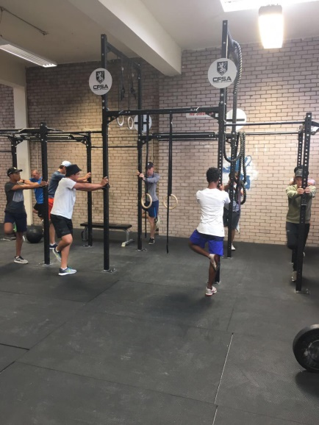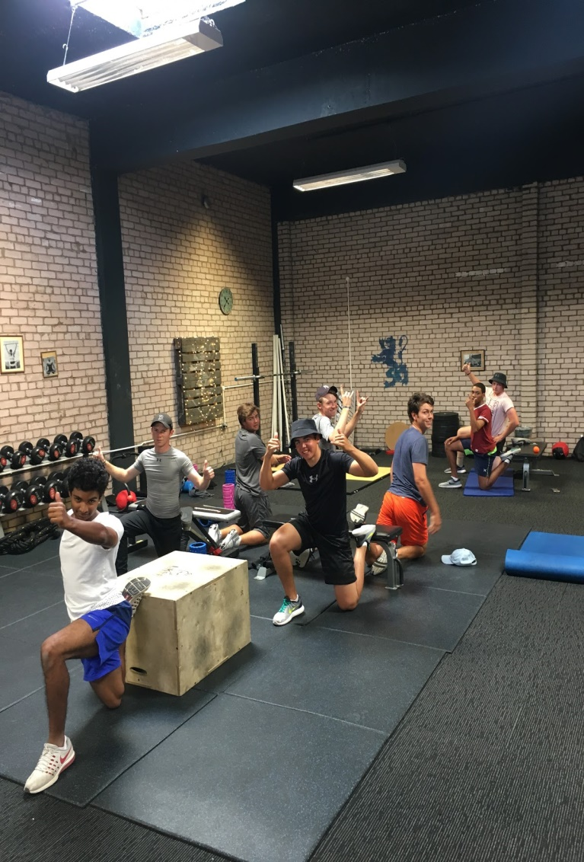

3. DANGERS FACING THE YOUNG GOLFER: EARLY SPECIALISATION

There are a number of stories around professional golfers and their introduction to golf at a very young age. Social media videos, magazine articles and documentaries share images of golfers like Rory McIlroy, Jordan Spieth, Justin Thomas and even Ernie Els playing junior events and winning tournaments in their early years. This kind of exposure creates an impression that in order to succeed as a pro golfer, early specialisation is necessary.

This notion has created a scenario where young golfers are dropping their participation in other sports in order to devote more time to their golf. This additional time leads to golfers spending more time on the driving range, putting green and golf course.

The challenge with dropping participation in other sports is the physical and emotional benefit of other sports. Other sports provide movements that help to strengthen the body, improve fitness, balance, coordination, power and speed: all aspects of fitness necessary for golf.

The danger with this early specialization is that young golfers are now more exposed to the practice loads of golf normally experienced by an elite amateur or professional golfer. Whilst the golf swing may not seem to be a very dangerous movement, it is primarily a unilateral (one-sided) movement, which when repeated numerous times starts to create muscle imbalances, postural changes and overload of certain areas of the body. When you add these characteristics to a developing body, or a physically immature body…the results can be catastrophic.

Overuse injuries in professional golfers are treated a certain way, which includes rest, physiotherapy, medication and perhaps even surgery in some severe cases. Thus for a young person to have to start dealing with these kinds of injuries, in addition to the challenges of their physical and emotional development from adolescence into adults often leads to burnout and career-ending injuries, before a career even begins.

Participation in golf, in addition to other sports allows the golfer to develop what we call movement literacy, or the ability to move well. It creates a more holistic athlete, a better balanced person and a longer career.

There are a number of examples of professional sportsmen and women who had extensive involvement in a number of sports, some even at provincial and national level, in addition to their eventual chosen sport. AB de Villiers was a scratch golfer, provincial tennis, provincial cricket and rugby player before choosing a career in cricket. Jordan Spieth had a history in baseball at high school level, Dustin Johnson in basketball and the list continues.

The role of golf fitness becomes even more important with golfers already specializing in golf. The exercise programs are designed to improve movement literacy, flexibility, strength, power, coordination and balance: components they could obtain from involvement in other sports.

4. GOLF ALL YEAR ROUND: THE CHALLENGE WITH TOURNAMENT SCHEDULE

South Africa is a country where golf can be played all year round, which is both a blessing and a curse for golf tournament schedules. In addition to golf all year round locally, there are numerous overseas tournaments that attract players from all over the world, including South Africa. This ability to play golf all year around presents a very serious concern for management of our golfers: overplaying and burnout.

A quick scan through the tournament schedule for Open ranking sees 27 events planned for the year, Junior events totals 24, and with overseas events in the UK, Italy and America, the reality of our golfers playing in excess of 30 events a year is high. Some of our junior golfers play both junior and senior events, which could total as many as 40 events. This trend can also be exaggerated with a ranking system that promotes busy schedules.

Unfortunately, this trend in busy schedules does not change once a player turns professional, where the European Tour has 38 events on their roster, while the PGA Tour boasts 52 events in their current 2016-2017 tournament schedule.

The solution to this challenge does not lie in the reduction of events, or even moving events around, but in the management of each player’s schedule. Listed below are a few factors to consider when looking at a player’s schedule:

      - Age of the player (chronological vs developmental)
      - Skill level of player
      - Physical condition of player
      - Ranking of player
      - Goals of the player
      - Educational stage
      - Financial means to play
      - Teams/squads/overseas exposure

If consideration to the above-mentioned factors is given, a better decision for the tournament schedule can be made, taking into account the short-term, medium term and long term goals of the golfer.

5. GOALS OF GOLF FITNESS

A golfer may have many reasons why they add fitness routines into their golf, and all of those reasons can be valid, but one thing is certain: all of those reasons need to lead towards an improvement in their golf. Anything that detracts from their golf performance should be reconsidered, and it is always better to get professional expertise in guiding the golfer along.

Listed below are a few reasons why I would consider adding golf fitness into a golfer’s programme:

- Functionality: The golfer needs to aspire to have a body that works well. A good functional body will allow the freedom to do whats necessary with the golf club
- Injury prevention: Golfer’s should avoid getting injured like the plague. It is a situation where once they have been injured once, the chances of being injured again are higher.
- Performance: The progression of the professional game has meant that golfers have become true golfing athletes. Bigger, stronger, fitter, more flexible golfers are able to compete week in and week out at a very high level, and with the demands of the golf courses in terms of length, the necessity to hit the ball further is a reality.
- Longevity: Golf is a unique sport in that golfers can compete in a very broad window of professional sport. There are a number of older golfers (40 and above) who are able to compete on a weekly basis with much younger professionals, due to their fitness and functional status.
- Periodisation: There are certain periods in the year where golfers need to be at their playing peak, which usually targets the majors and playoffs for the FEDEX Cup and Race to Dubai on the professional side. The necessity of monitoring energy levels and loads is an important part of the fitness regimes.
- Routine: Golf is about controlling the controllable factors, of which routines form a part of. The physical preparation for a round of golf, and the recovery session after a round of golf help the golfer create more consistency in their performance, as well as their preparation for each round.

6. COMPONENTS OF GOLF FITNESS

Mobility
Mobility can be broken up into two components. Firstly, the flexibility or length of a particular muscle or combination of muscles, and secondly, range of motion around a joint or combination of joints.

Mobility is an essential building block around any athletic movement, as mobility is what gives us a movement in the first place. A sufficient amount of mobility will allow the golfer do what is necessary with the golf club. There are certain joints or areas of the body that are designed to be more mobile than others.

The areas of mobility include:
  - Ankle (Calf muscle)
  - Hip joint
  - Thoracic spine (mid back)
  - Cervical spine (neck)
  - Glenohumeral (shoulder joint)
  - Wrist

When an area of the body becomes immobile, or stiff, movement is lost and must be “borrowed” from adjacent areas to ensure that the body continues to move. As an example, if the hip joint is tight, the body will “borrow” movement either from the area above the hip (lower back) or below (knee) to make up for the loss of movement. This “borrowing” of movement places additional load on the adjacent areas, and either pain or injury could result. Golfers with lower back pain commonly experience tight or limited hip movement.

Stability:
This is the ability of the body to control the movement gained through mobility. There are certain areas of the body that have a primary function of stabilization, or providing an anchor for movement to occur:
  - Foot
  - Knee
  - Lumbar spine (lower back-core)
  - Scapulae (shoulder blades)
  - Elbow

These areas provide support for the adjacent mobile regions of the body, and allow the body to move in a coordinated, balanced manner. If there is a mobility limitation in one of the areas mentioned earlier, the areas of stability are usually the first to be compromised. A stable lumbar region or lower back is essential for the golfer to maintain posture, create speed and power, and transfer that power from the lower body to the upper body, and ultimately, the golf club. A stable core region also provides the necessary support to the spine, preventing lower back pain and injuries.

Balance:
Balance can be divided into a static balance, which involves a golfer’s weight distribution between left and right foot, toe-heel and inside-outside the foot at address, and secondly dynamic balance, which is how weight is transferred during the golf swing. Both elements are important and a golfer needs both to create a repeatable golf swing. Our balance can be affected by a number of factors, including variable leg length, poor ankle mobility, neural issues, vertigo, medication and shoe design.

Posture:
Posture is such a vital component of golf fitness, but is affected by so many components. The single biggest difference between the professional golfers and amateur golfers is the ability to maintain good posture throughout the golf swing. A tall spine, good hip hinge, and just the right amount of knee flexion can be the difference between a very erratic golf swing (or in serious cases, injury) and a great golf swing. Posture of younger golfers has become increasingly dysfunctional, with the arrival of the technology age and increasing dependence on cell phones, there are more and more golfers suffering from poor posture mechanics, and poor postural control.

Coordination:
Coordination is the ability of the athlete to move his/her body in a synchronized, intentional movement. This aspect of fitness is one of the areas most affected by sedentary lifestyle and early specialization. Coordination is non sport-specific. An example of coordination is the ability to skip, or jump and land safely, throw, kick, crawl etc.

Speed:
The ability to execute a movement in a very short amount of time. Acceleration forms part of speed, and as club head speed is such a vital component to distance in golf, a golfer’s capacity to generate speed is important. Much of a person’s ability to create speed depends on their genetics and their exposure to various sports during their adolescent years. Speed can be generated or developed later as a young adult, but capacity is limited.

Power:
Power is a function of strength as well as speed. A golfer needs to have sufficient amounts of strength to execute a movement, but they also need to be able to execute the movement in a short amount of time. An example of this is the vertical jump test. The test evaluates an athlete’s ability to jump by measuring the difference in their reach height to a maximum jump height. The athlete needs to have sufficient strength to create the power to propel their body weight off the ground, and the speed to be able to explode off the ground. Power in golf can be generated from three main sources, namely the lower body, core (abdominal region) and upper body. These power sources should be in balance with each other and can be measured.

Cardiovascular Fitness:
Cardiovascular fitness is the ability of the cardiovascular system to adapt to exercise intensity. The heart rate response, breathing rate and capacity, and circulatory system should work as efficiently as possible to keep the body working well. Fitness is usually improved through interval-based cardio. Cardio fitness is important for golf mainly through the benefits of fitness, namely stronger or more effective breathing mechanisms, efficient heart rate adaption and ability to recover after a strenuous walk. Stress levels are also affected by breathing patterns, and controlling your heart rate and breathing in stressful situations can be the difference between winning and losing.

Cardiovascular Endurance:
Endurance is important for golf in keeping or sustaining energy levels throughout the round or tournament, as well as maintaining exercise intensity over a period of time. Cardio endurance training can also be used for weight maintenance and management.

7. INJURIES: THE BLACK MARK THAT NEVER GOES AWAY

One of the main motivations for golf fitness should be injury prevention. An injury to a golfer not only prevents a golfer playing for the duration of the injury, but affects the golfer both physically and psychologically for a period of time after the injury occurs, as the golfer deals with issues of trusting that injury will not re-occur.

The timing of injuries can be career shaping. Tiger Woods is one of the fittest golfers of his era, but his career is littered with injuries, ranging from Achilles tendon, to knees, back and neck. What would Woods’ career look like today if he had not picked up the injuries he did?

Injuries with amateur golfers may be caused by a number of factors, and it is imperative that these factors be considered when looking at the long-term development and management of our youth:

- Equipment: Golf equipment that is not fitted to the golfer and their ability can be tremendously detrimental to their golf game, as well as their health. Golf clubs too long for a young golfer change not only the static posture of the golfer, but will affect how their body moves in the golf swing to accommodate the extra length, which could change their swing mechanics. The weight of the club will affect the golfer in a similar fashion, thus the necessity for graphite shafts or lightweight steel is a factor to consider.
- Injury History: Once a golfer picks up an injury, the affected area will always be a weaker point in the body, and thus increase the likelihood of another injury in the future.
- Inflexibility: A golfer with a flexibility issue somewhere in the body is more likely to develop an injury, as the body compensates for the lack of range of motion; it overloads another area of the body.
- Asymmetry: Golf as a movement is very one-sided physical motion. This one sided motion develops each side of the body differently, eventually leading to differences in muscle size, flexibility and even balance between left and right hand side. This asymmetry will eventually cause excessive compensation and injury.
- Swing Mechanics: Poor posture, inconsistent swing mechanics and over-practice habits can also lead to injury. S-Posture, Early extension and reverse spine angle are three swing patterns that have a direct correlation to lower back pain.
- Practice surface: The surface off which golfers hit golf balls may also contribute to injury. Artificial mats sitting on top of a paved or concrete surface creates an unnecessary jarring effect every time a golfer hits a ball. This effect, multiplied every time a ball is struck, can leads to wrist, elbow or even shoulder injuries.

Acute vs Chronic Injuries
In most sports, there is always the chance that an athlete will pick up an injury due to factors outside of their control. A bad tackle in soccer or rugby, cricket bail in the eye or even falling off your bike from being hit by another cyclist are situations that are unavoidable.

In golf, this could be a scenario where a golfer strikes a root or rock hidden below the ball, or perhaps slips climbing in or out of a bunker. These types of injuries are defined as acute, or instantaneous.

There is another type of injury that is found in golf, that is related to a repetitive movement that overloads the body in such a way that it results in an injury. This injury progresses in seriousness as time goes on, and is a more common injury in golf. These injuries are often caused by the factors mentioned above, and can be prevented.

In professional golf, the wrist is the area of the body most affected by overuse, followed by the joints on the lead side (elbow, shoulder, knee, ankle, lower back). In amateur golf, lower back pain is the leading overuse injury, with one in two golfers being affected by back pain at some point. This is then followed by injuries to the joints on the left side.

The reality of early specialisation in golf is creating a situation where younger golfers are picking up overuse injuries at an alarming rate. Wrist injuries, lower back conditions and postural issues are becoming the norm in junior golf as our young golfers hit hundreds of golf balls every week, play upwards of 20 tournaments a year and do not look after their bodies.

8. WARM UP AND PREP

Golf, much like most other sports, requires the athlete to be able to perform from minute one of competition. The physical load of a golf swing on the body requires that the body be physically prepared to move well.

The golf swing is a coordinated, multi-plane movement executed with precision and power, with many moving parts. It is essential for a golfer then to be best prepared for a round of golf, and since the body is the literal engine of the golf swing, it is essential that the body is best prepared for the physical requirements of a golf swing.

The wonderful world of technology, and social media, has allowed the golf industry to glimpse into the preparation habits of professional golfers, leaving no stone unturned in terms of the details of their preparation. Most golfers spend anywhere from 30 to 90 minutes warming up on the driving range, chipping and putting greens, preparing for their round of golf. In the era of Tiger Woods, we have seen the evolution of the physical warm up prior to the driving range warm up. This physical warm up is used to prepare the body for the range warm up.

A 2014 study was conducted into the effect of the physical warm up on driving distance, clubhead speed and ball speed. The results showed that a dynamic (movement-based) resisted (resistance band) warm up had a positive effect on all three variables
In addition to the obvious performance benefits of a physical warm up for golf, the warm up may also assist in:

- Swing efficiency: A golfer can find their timing on a particular day faster as their body already warm from the physical warm up
- Feel: difficult to tangibly develop but golfers need to be able to feel the club moving, which can be done quicker and once the body is warm
- Injury prevention: cold bodies do not move well initially, thus swing mechanics can be inconsistent in the range warm up, especially in cold conditions, thus a physical warm up can increase body temperature prior to a golfer beginning with a range warm up
- Consistency: Golfers understand that with the nature of golf and its variables, consistency from one day to the next can be different. A consistent physical preparation can bring a more consistent feel to the warm up.

9. COOL DOWN AND RECOVERY
This area of golf is not often focused on, or given the necessary attention it deserves. Cool down and recovery strategies are more often associated with other sports, particularly sports that are more physically demanding, like rugby, soccer or cycling. A good recovery strategy in golf will not only help prevent stiffness and tightness post-round, but will assist in performance in the days that follow.

Golf is a complicated sport in that it is played over a number of hours, at a relatively low intensity with a very explosive high intensity golf swing every few minutes. Golf requires moments of intense focus and concentration, a high level of skill and the ability to perform over a number of days.

If environmental conditions, weather delays, practice rounds and practice are added to the situation, recovery becomes a key factor to consistent performance. A good post-round recovery routine is a critical part of a multi-day, multi-week tournament schedule.

From a physical standpoint, a recovery routine’s aim is to return the body to a base level. This can be from a postural standpoint, a nutritional standpoint and even a neurological standpoint. Rejuvenation of the energy levels will assist in the accumulative fatigue on the body over a tournament.

Listed below are a few areas that should be considered when looking at recovery:

- Post-round stretching routine: static stretching and foam rolling will assist in posture reset, relieving sore or tight muscles and help with stiffness
- Hydration: a good mix of water and electrolyte intake will replenish any water loss sustained on the course through sweating
- Nutrition: A well balanced meal of protein, carbohydrates and fats will not only replenish energy levels that would have been lowered in the round, but a good meal will also help fuel the body for any activity
- Ice bath/swim: Much research has been done into ice baths and the recovery of muscle in many other sports, and the same benefits can be experienced when using ice baths for golf.
- Naps: an early tee time may require the golfer to catch up on a brief nap in the afternoon. Research suggests that 20-25 minutes will have a positive effect on energy levels, cognitive awareness and neurological recovery.

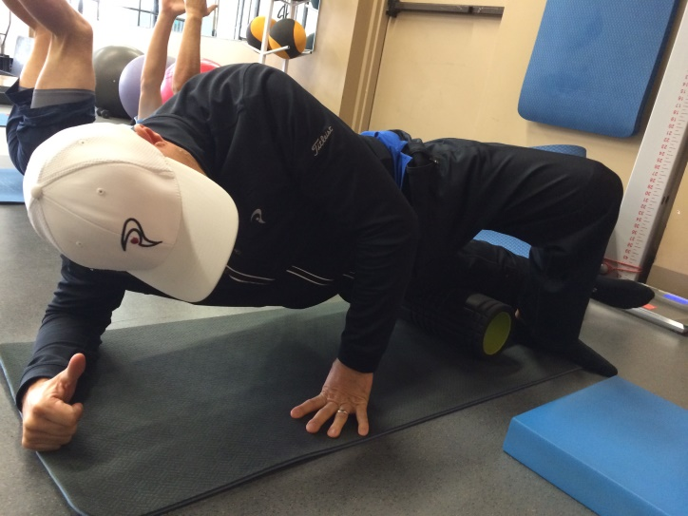

10. NOTES ON NUTRITION

Nutrition for golf is an area often neglected on an amateur level, especially by the social golfer. Many golfers are misled by focusing on what they should be eating, instead of how they should be eating.

Eating patterns in golf can easily be corrected, but does require some intentionality on the part of the golfer. There are a number of barriers that a golfer would need to overcome in order to create and establish good eating patterns on the golf course.

These barriers include:
- Halfway house: most South African golf courses have been designed with both 9 holes loops finishing at the clubhouse. Golfers are thus able to stop midway through their round to eat something, which creates a pattern of only eating once in 18 holes.
- Food availability: the food that is made available at the halfway house is often convenience food, which is not necessarily healthy
- Convenience: In order for the golfer to pack food and snacks into their golf bag, it requires planning and foresight. It is often just more convenient to find food at the golf course.
- Finance: snacks can be expensive, and packing snacks for multiple rounds can be a pricey exercise.

What are good nutrition patterns on golf day?
- A balanced meal ingested 90-120 minutes before tee-time
- Small snacks on the golf course every 4-6 holes, with no meal at halfway
- Snacks should include a balance of protein, carbohydrates and fats
- Post round recovery meal similar in structure to pre-round meal
- Hydration: a minimum of 1 liter of water per 30kg of body weight per day. 50% of your daily intake should take place on the golf course
- E.G a 90kg male should drink 3 liters of water a day, which works out to 1.5 liters on the golf course.
- Simple and high sugar foods and drinks should be avoided

The real discussion point is why good nutrition? Why is it so important for a golfer to eat well?
- Good nutrition is one of those components where you don’t really notice the effects of good nutrition, but rather the symptoms of bad nutrition. No snacks on the golf course, or a large meal at halfway can leave the golfer either feeling lethargic, irritable and moody, or lethargic and less athletic. Either way, optimum performance is affected, and mistakes will be made.
- Regular snacks allow the body to regulate blood sugar levels. An inconsistent blood sugar level has been linked to loss of concentration, altered mood levels, mental errors and decreased physical performance. Food ingested that is high in simple sugars will result in blood sugar spikes, followed by blood sugar lows, which can be dangerous to the body if not corrected.

Helpful tips on nutrition and hydration
- Use practice rounds and social rounds to find a nutritional pattern that works for the golfer. Some golfers prefer to snack every four holes, some every six holes.
- Take note of the golf course and range of food available. It may be necessary to purchase food elsewhere
- Intentionality into packing snacks the day before can be helpful
- Perishable snacks (sandwiches, fruit) can be eaten earlier in the round, with longer-lasting snacks (nuts, dried fruit, biltong) ingested later on
- Meal replacements (shakes) should have a balance of protein, carbohydrates and fats. Care should be taken into which supplements are acceptable in terms of prohibited substances.
- Try to follow a 2:1 ratio in terms of water to electrolyte drinks. In other words, two bottles of water for every one bottle of electrolyte drink.
- Stimulants like caffeine should be avoided during a round of golf
- It is always better to consult with a nutritionist to personalise your snacks and supplementation.

11. REFERENCES
      - http://www.mytpi.com/articles/fitness/the_science_behind_a_golf_warm_up?search=warm%20up
      - http://www.mytpi.com/articles/health/hydration_basics?search=hydration
      - http://www.mytpi.com/articles/health/injuries_in_professional_golf_-_what's_going_on?search=injuries

Gavin Groves
GolfRSA/TuksGolf
Gavin is the fitness expert for GolfRSA’s National Squad. He also heads up the Strength and Conditioning department of the TuksGolf academy, working with junior golf coaches and fitness for young players, through to various elite level players, Sunshine and European tour players and winners. Gavin has an honours degree in Biokinetics from the University of Pretoria, is Titleist Performance Institute (TPI) qualified and has completed his PGA Diploma.

